**Practical Exercise - Walkthrough**

**Attach to the PDF Reader window using an Attach Window activity.**

* Drag an **Anchor Base** container inside the **Do**block:
  + on the left side, we’ll drag a **Find Element** activity to select our anchor.
    - we click *Indicate on screen.*
    - we click the DATE label next to the actual date we are trying to get.
  + on the right side, we’ll drag a **Get Text** activity to read the value we want.
    - we click *Indicate on screen.*
    - we click the actual date field we are trying to get (e.g. 6/6/2016).
    - note that the selector only contains a tag with a type attribute.
    - in the **Output** property, create a new variable to hold the read value.
  + in the properties of the **Anchor Base** container, set the **AnchorPosition** to **Left** or **Auto**.

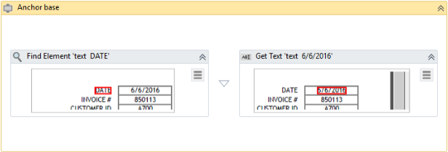

For the second anchor-based reading, we use a similar method.

* we drag an **Anchor Base** container inside the **Do**block.
  + on the left side, drag a **Find Element** activity to select our anchor.
    - we click *Indicate on screen.*
    - we click the BILL TO label on top of the address we are trying to get.
  + on the right side, drag a **Get Text** activity to read the value we want.
    - we click *Indicate on screen.*
    - we click the actual address field we are trying to get (e.g. IDES AG Frankfurt).
    - note that the selector only contains a tag with a type attribute.
    - in the **Output** property, create a new variable to hold the read value.
  + in the **Anchor Base** container, set the **AnchorPosition** property to Top or Auto.